Name:

Choose your own
History
Project
UDL Based Research Projects

Autobiography
What is an autobiography? The written account of a person's life written by that person.
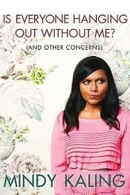
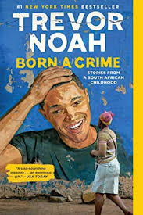
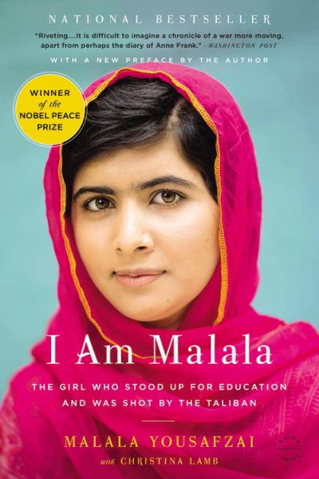
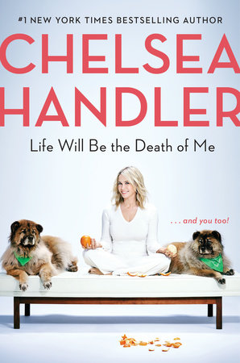
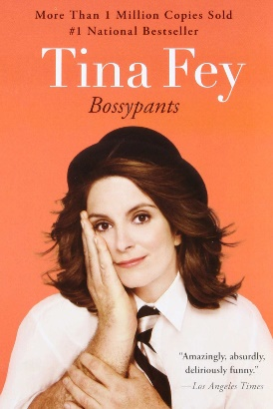
Examples of Autobiographies

For this project option, your task is to write one chapter (not the whole story as you cannot write a well-written autobiography in only three pages) of an autobiography that relates to the unit/topic we are studying in class. How do you even write an autobiography about history? Well you can go two ways with this. Option one; write a historically accurate autobiography from the perspective of a person (real or not). For example, if we are studying WWI you can write from the perspective of fictional nurse or you can research a real nurse and imagine what she would write if she wrote an autobiography. Option two; write your chapter about you if the topic we are studying has a personal connection to yourself. For example, if you had family affected by WW1 and that is what we are studying, write about it. You must connect it back to you and how it has affected you and your identity since an autobiography is about the person who is writing it.
Mandatory Criteria:
- 1 book cover with title, author and image (colourful and reflective to what you wrote)
- Must write one well worded chapter ( any point in the book, beginning , middle or end)
- Three written pages, 1.5 spaced , Times new Roman, size 12 font or 700 word minimum
- Separate page with MLA format bibliography of minimum of 5 credible research sources
- Main focus/ topic that relates to what we are studying
- Must contain historically accurate information
- Must highlight you understanding of the subject area being studied
Remember: Five pages total, title page ( book cover), 3 pages and MLA bibliography

Biography
What is a biography? A biography is a detailed description of a person's life written by someone who has studied him or her. It involves more than just the basic facts like education, work, relationships, and death; it portrays a person's experience of these life events.
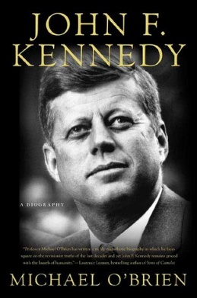
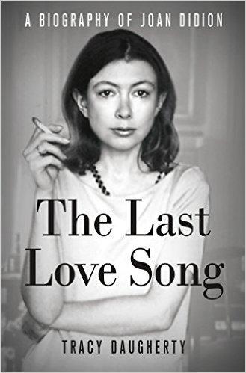
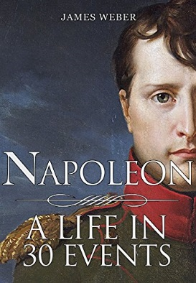
Examples of Biographies

For this project option, your task is to write one chapter of a biography. The reason why it is a chapter verses a whole biography is a writing a chapter allows you to focus on just what we are learning about in school. Your chapter can be any chapter in this book but it needs to relate to what we are learning in class and highlight historically accurate information. Not interested in minor details of the person’s life but what they did that made them a significant person to study. For example if studying WW2 and you wrote about Winston Churchill, write your chapter about his role as Britain’s Prime Minster during wartime and not his childhood.
Mandatory Criteria:
- 1 book cover with title, author and image (colourful and reflective to what you wrote)
- Must write one well worded chapter ( any point in the book, beginning , middle or end)
- Three well written 1.5 spaced, Times New Roman, size 12 font or 700 word minimum
- Separate page with MLA format bibliography of minimum of 5 credible research sources
- Main focus/ topic that relates to what we are studying
- Must contain historically accurate information
- Must highlight you understanding of the subject area being studied

Remember: Five pages total, title page( book cover design) , 3 pages and MLA bibliography

Create an Award
What is an award? A formal occasion at which prizes are given to honor achievement in a particular field.
If you pick this option, you have a few outcomes you need to complete.
First, you need to create prestigious award with qualification. For example, if we are studying explores the award could be called The Great Prize of Exploration and the qualification is significant contribution in the field of discovery with global impact. You also need to include a drawing of what the award would look like; think about what we are studying and how to represent that in symbols.
Second, write a one page on why the person is getting the award. What did they did that was so great, what qualities they have that makes them outstanding and the impact they have made.
Third, write the acceptance speech in historical perspective of the person winning the award, thanking people who have helped them and why they did what they did. Writing using historical perspective means include names of people they know, writing with the tone of the era and using the context vocabulary, no current slang.
Remember the award must relate to what we are studying
Mandatory Criteria:
- 1 page containing what the award is called, qualifications and what the award looks like
- The award must be well illustrated and contain symbols that relate to the award/topic
- Size 12 Times New Roman, 1.5 spaced
- One page about why the person is winning the award ( their contributions)
- 1.5 – 2 page thank you speech
- Separate page with MLA format bibliography of minimum of 5 credible research sources
- Main focus/ topic that relates to what we are studying
- Must contain historically accurate information
- Must highlight you understanding of the subject area being studied

Create a Blog
What is a blog? A regularly updated website or web page, typically one run by an individual or small group, which is written in an informal or conversational style.
For this project, you will create an actual blog using blogger.com, wordpress.com or other blogging platforms!
You have a few option with how you will construct your blog.
- Diary, your blog can be an online diary written with historical perspective. You would construct five posts that are a minimum of 200 words each. The posts are historically dated and will flow together to explain an event or topic relating to area of study. For example if we are studying the suffragette movement you can write your blog diary from the perspective of Nellie McClung and each post would provide information regarding information on why she fought for women’s right, why women didn’t have voting rights to begin with and what she plans to do to get the right to vote.

Or

- Your blog can be about topic in relations to what we are learning and you create one 700 word post about something significate to what we are studying. For example, your blog could be titled Amazing Women around the Word and your post is about Nellie McClung.
Mandatory Criteria:
- Must create a working blog online that visually reflects the topic of study
- The blog must include images
- The blog must have hyperlinks citing a minimum of 5 credible research sources
- Main focus/ topic that relates to what we are studying
- Must contain historically accurate information
- Must highlight you understanding of the subject area being studied

Ask for help if you do not know how to start creating a blog or how to input hyperlinks

Create a Diary
What is a diary? A personal book in which one keeps a daily record of events and experiences.
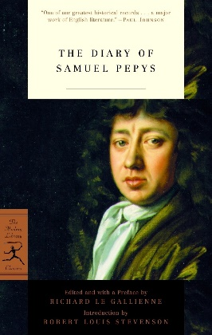
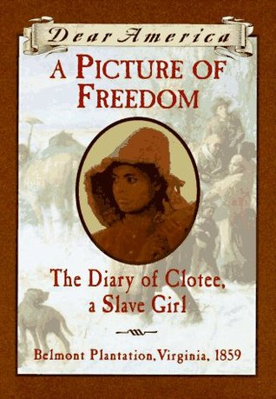
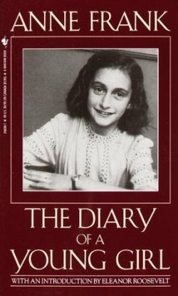
Diary Examples

Writing a diary will be in-between a blog and autobiography. Your diary has to be written with historical perspective, meaning writing with the language of the era, including important names and events. You are essentially envisioning writing as this person. Your diary can be written from the point of view of a real historical person or a person you created, but both need to be researched in order to gain insight of how this person would have lived. Your diary will be a 3 - 5 diary entries with a minimum of 700 words total. Each diary entry must be dated, hand written and doubled spaced. Diary entries must flow together to tell a story that is significant to what we are learning in class.
Mandatory Criteria:
- Must write 3 – 5 diary entries, 700 words
- Hand written, double spaced
- Dairy must include a creative element such as drawings, pictures ( printed form the computer is fine), stained paper to make it look old
- Separate page with MLA format bibliography of minimum of 5credible research sources
- Main focus/ topic that relates to what we are studying
- Must contain historically accurate information
- Must highlight you understanding of the subject area being studied

Please type it up on the computer first so you can easily edit your writing and then hand write it. Being able to hand write is still an important skill to have!

Book Club
What is a book club? A book club is a group of people who meet to discuss a book that they have read to discuss their opinions, likes, dislikes, etc.
In this option, you will find a book to read that relates to what we are learning in class. The book can be a biography, graphic novel, children’s book, historical fiction; just about any book will work as long as it has historically accurate content that you can discuss. After reading the book you will write, a one page summery about the book and another one page write up about what you learned from the book. Once done the writing portion, you will then schedule time with the teacher to share your project to the class. You will read a summary of what you wrote to the class as well as a small paragraph from a part of the book that supports your write-ups. If the book is less than 50 pages, your deadline is the same as the rest of the class and you are expected to be reading the book in class while other students are researching their projects. If the book is more than 50 pages, you will get an extension but you must show up to class ready read during designated project periods.
Mandatory Criteria:
- Must read a book that fits in with what we are studying in class
- 1 page summary of the book
- 1 page write up about what you learned
- Size 12, Times New Roman, 1.5 spaced writing
- Class presentation about the book
- Must read a small paragraph from the book that supports what you learned
- Project must contain historically accurate information
- Project must highlight you understanding of the subject area being studied
- Separate page with MLA format bibliography of minimum of 5 credible research sources

This project involves using your reading comprehension and public speaking skills

Children’s Book
What is a children’s book? A book targeted towards a younger audience that often includes illustrations to accompany the writing. Children’s books tend to have an education undertone in the writing whether it is from colour recognition, teaching kids to cope with their emotions or teaching kids about history.
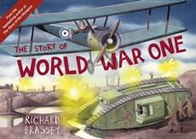
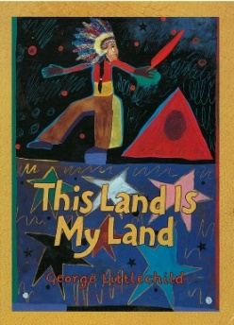
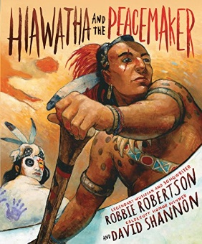
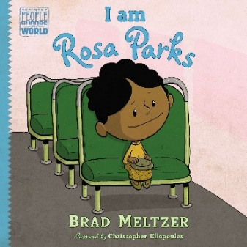
Children’s Book with Historical Content Examples
In this option, you will get to create your own illustrated children’s book! To start, head to the library for research! Read a few historical children’s book to get an understanding of how they are laid out, worded and how the illustration reflect the story. Once you get a good feel for how to construct a children’s book start your research and then rough draft for your children’s book! Before you create your good copy make sure you show the teacher your rough draft to ensure you book has enough historical content that reflects what we are learning in class and the information reflection grade level content.
Mandatory Criteria:
- Illustrated cover with title and author/ illustrator
- Illustrated back cover with short book synopsis
- Book must be 10 pages
- Book must have hand drawn illustrations fully coloured on each page
- Book must reflect historically accurate information ( in both the writing and illustrations)
- Book must highlight a high school level of learning
- Book must be regarding a topic we are currently studying
- Book must me crafted with care and detail
- Stick figures, no frames, illegible writing, not fully coloured or shaded will get an automatic 0 in the criteria portion of the rubric
- Separate page with MLA format bibliography of minimum of 5 credible research sources

This is a great option for students who like to draw
Graphic Novel
What is a graphic Novel? A story that is presented in comic-strip format and published as a book.
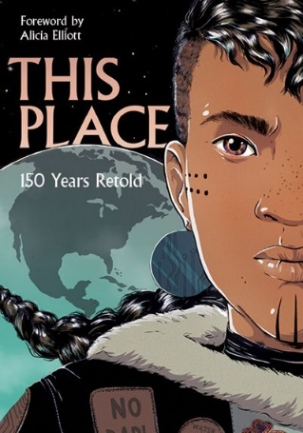
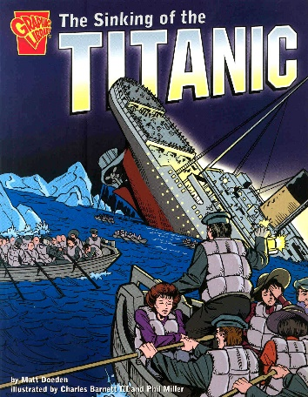
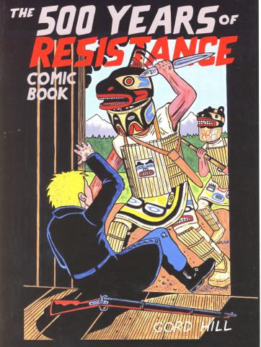
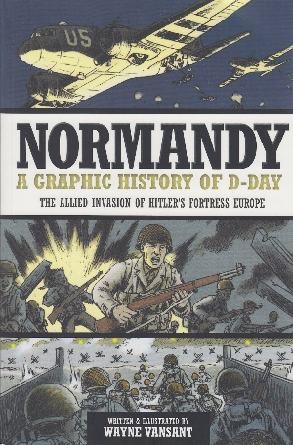
Examples of Graphic Novels with Historical Context

This option is similar to the children’s book option except that instead of illustrated pages you will dived your pages up into comic strip, called frames. Historical content will presented through dialogue and images in this option. To begin go research how a graphic novel is laid out and then start researching your topic and figuring out how you will display in in this format. Once you have a rough draft of what you will put in your graphic novel start your good copy. You can do it on the computer if you know how to use Adobe Illustrator, Krita or other computer programs or you can hand draw graphic novel. If drawing you need to draw your graphic novel on large paper in order to ensure you have enough room for both the drawing and text. You are not allowed to draw stick figures and the text must be legible.
Mandatory Criteria:
- Illustrated cover with title and author/ illustrator
- Illustrated back cover with short book synopsis
- Graphic must be 6 pages
- Each page must have 2 – 5 frames on the page
- Must be well shaded or coloured
- Must reflect historically accurate information ( in both the writing and illustrations)
- Must be about a topic we are currently learning in class
- Stick figures, no frames, illegible writing, not fully coloured or shaded will get an automatic 0 in the criteria portion of the rubric
- Separate page with MLA format bibliography of minimum of 5 credible research sources
This is a great option for students who like to draw
Informative Poster
What is a poster? A single poster that tells the audience something they probably do not already know. Typically, well explained facts that are interesting and presented in an attractive manner.
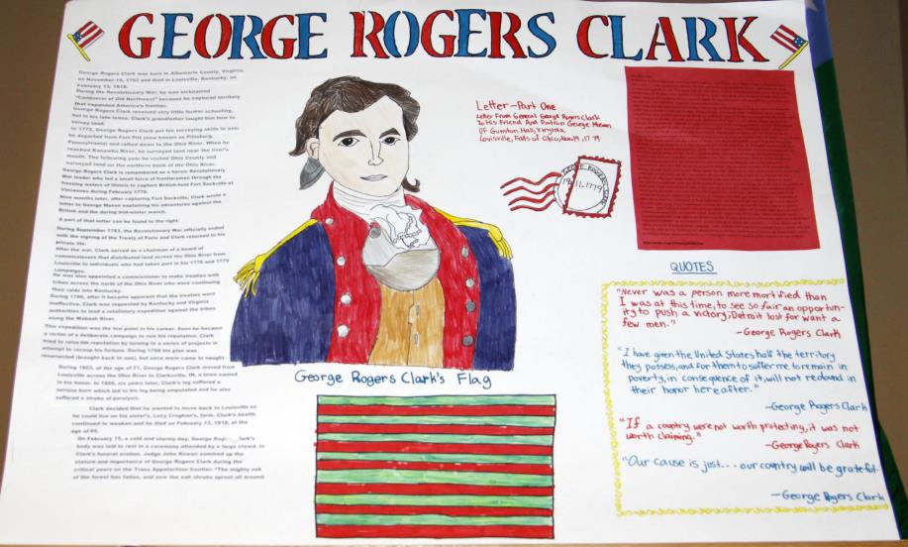
For this option, you need to create an attractive informative poster about a topic related to what we are studying. Your poster needs to have a title, six subtopics with titles, 200 word write up for each subtopic and images for each sub topic. It is up to you to pick your topic and subtopics but they need to give informative information at the high school level about what we are learning. For example if your poster is on a person the focus should be about why they historically significant, what they did and how they affected the world. It is okay to do one subtopic about their personal life but do not do a bunch of separate subtopics on family, education or other topics that are not touching on why this person (or event) is important. Your poster does not has to be about a person, you can dedicate your poster to explain a topic. For example, you can create a poster that explains why WW1 started and then create six subtopic about WW1 outbreak factors.
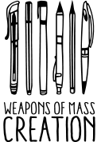
Mandatory Criteria:
- Created on 1 or 2 sheets of poster paper
- Poster must be attractive and made with care
- Poster must have visuals ( drawing, photos, graphics)
- Poster must be styled to reflect the theme of the topic
- Poster must have a title
- Poster must have 6 subtopic
- Each subtopic needs a minimum of 1 image
- Each subtopic needs to be 200 long
- Poster information must be typed or legible
- Must reflect historically accurate information ( in both the writing and illustrations)
- Must be about a topic we are currently learning in class
- Separate page glued on the back of the poster in MLA format bibliography of minimum of 5 credible research sources

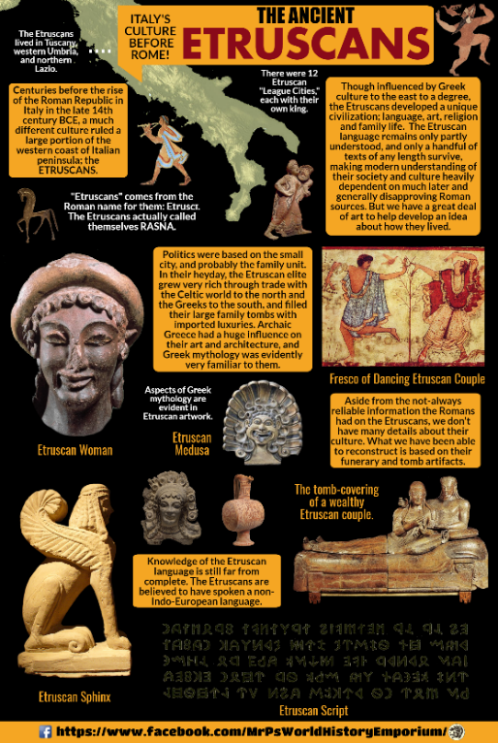
Infographic
What is an infographic? An infographic is a collection of imagery, charts, and minimal text that gives an easy-to-understand overview of a topic. As in the example below, infographics use striking, engaging visuals to communicate information quickly and clearly.

Creating an infographic is similar to the poster option but is done on the computer using Piktochart, Canva or other program. To begin research your topic and figure out what you want to write for your six subtopic. When ready start your write up your poster information in Word or Google Doc, the reason for this is the programs online will not have a good enough spell check. Next do some research on infographics to get some design inspiration. When ready start constructing your project, make sure to make it visually stimulating with graphics, boarder, backgrounds, images and more. Next copy and paste from your Word/Google Doc write up into your infographic. Do not do cut, so if you accidently deleted your infographic text box (which happens) you still have your Word/Google Doc to re copy from.

Mandatory Criteria:
- Infographic must be attractive, fully coloured, visually stimulating and made with care
- Infographic must be styled to reflect the theme of the topic
- Infographic must have a title
- Infographic must have 6 subtopic
- Each subtopic needs a minimum of 1 image
- Each subtopic needs to be 200 long
- Must reflect historically accurate information ( in both the writing and picture)
- Must be about a topic we are currently learning in class
- Hyperlink bibliography of minimum of 5 credible research sources

The teacher will go over how to make an infographic in more detail

Magazine
What is a magazine? A periodical publication containing articles and illustrations, typically covering a particular subject or area of interest.

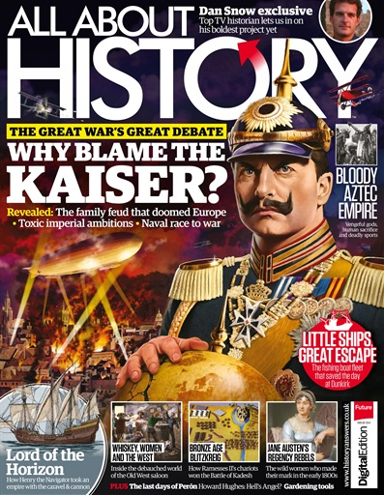
You have the choice to create your magazine on the computer or by hand! If you choose the computer option, you can use Microsoft Publisher or an online program like Canva. First start by picking a topic and six subtopic, then begin your research. Once you have all your research notes start typing up your six subtopic articles (minimum 200 long each) in Word/Google Doc. Don’t worry about designing your magazine until you have finished typing your articles. If you are hand making your magazine you will still type of your articles and print them out to glue in the magazine pages. If creating your magazine in Publisher of other software you can start designing your magazine. Once you have a magazine layout you like start copying and pasting your articles into the magazine. Remember to look through a few magazines for layout inspiration.

Mandatory Criteria:
- Magazine must be attractive, fully coloured, visually stimulating and made with care
- Magazine must be styled to reflect the theme of the topic
- Magazine must have a cover with title and headliners
- Magazine must have 6 articles with titles
- Each article needs a minimum of 1 image
- Each article needs to be a minimum of 200 long
- Must reflect historically accurate information ( in both the writing and picture)
- Must be about a topic we are currently learning in class
- Magazine must have a back page with MLA format bibliography, minimum of 5 credible research sources

The teacher will go over how to make a magazine in more detail

Slide Presentation
What is a slid presentation? A series of pictures or pages of information (slides), often displayed on a large screen using a video projector.

This option require you to create a proper slide presentation! This means you will not stand in front of the class reading off your slides but instead you will read from the notes you have prepared and the slides will provided images, key points, videos and other media to accompany your speech. Just like every other project option, you need to research your topic and come up with six topics for your presentation. After researching, in Word/Goggle Doc start typing up what you would like to present to the class, these will be your speaker notes. Once you have you speaker notes complete start making your slide, you need one title page slide, 6 slides one for each sub topic and a work cited slides with 5 hyperlinks from the sources you used. Presenting is mandatory to the class, if you don’t want to present then do not pick this option. You can choose to create your slides on PowerPoint, Prezi or Google Slide

Mandatory Criteria:
- Slide must be styled to reflect the theme of the topic
- Slides must be attractive and visually stimulating
- Must have a title page slide
- Must have a minimum of 6 slides with images
- What you are saying must visually math the slide
- You need to explain the images in the slide as part of the presentation
- Presentation must be 8 – 15 minutes long
- Must reflect historically accurate information ( in both the writing and picture)
- Must be about a topic we are currently learning in class
- The last slide must have 5 hyperlinked credible references
- Student must hand in both slide presentation and speaker notes

Video Montage
What is a montage? The process or technique of selecting, editing, and piecing together separate sections of film to form a continuous whole.
Essentially, you will be collecting videos clipping and images that you will formulate into a video with text and background music. First, research your topic and then compose it into 10 well-worded facts that are of high school level. Next find images and video clipping to accompany each fact. Each fact needs either one video clipping or three images. Keep in mind our eyes get board of a still image after 3 seconds! You can use a YouTube to MP4 converter website to download your video clips. Once you have your facts and all your images/video clipping you can start constructing your movie in Movie Maker or other video making software. The teacher will show you how to construct your video during work periods, but in a nutshell start with creating a tile page and then getting in the images/video for each fact. Once all the visuals are in, add in the text, make sure the timing of the text and images are aligned and then add in credits with 5 sources. Last, find background music to accompany your movie. Make sure you watch your video before you convert it into movie format! Again, the teacher will help you with all the tricky technical aspects of this project.

Mandatory Criteria:
- Movie has title page
- Movie has 10 well worded facts with images and video clips
- Movie has background music appropriate to fit the theme of the movie
- Movie is played to the class
- The movie reflect historically accurate information ( in both the writing and picture)
- The movie about a topic we are currently learning in class
- The movie ends with credits with 5 credible references
- The movie is well edited and timed
- All images and video clippings are of good quality
- Images and videos reflect the facts visually

The teacher will go over how to make a movie in more detail

Podcast
What is a podcast? A digital audio file made available on the Internet for downloading to a computer or mobile device, typically available as a series, new installments of which can be received by subscribers automatically.
Before you jump into to the technical part, you need to research your topic and figure out what you want to say in your pod cast. Once you have the information of what you want to talk about, go listen to a few podcast to get a feel for how people talk in a podcast and other production elements. Podcast can have humor and be causal but don’t let the humor over shine informative part of the podcast. After getting some inspiration, start writing up the narrative of your podcast. Your podcast must open with the name of your Podcast series, your name and what you are going to talk about today. Your podcast must be informative and 3 minutes long, give or take 30 seconds. To reference the sources used in your Podcast you will simple just say what resources you used and why, this will be after the 3 minutes point. The reason for this is to organically include and pay credit to the sources you used rather than submitting a bibliography. When you are ready to record you will use Audacity or other software, the teacher will help you get started. A good recoding tip is to read one sentence at a time and then stopping to listing to what you just recoded to ensure its good, if it has not then deleted that track and restart again. Once done recording and in royalty free background music and then convert the Audacity track into an MP3 file and drop it into the class folder. Again, the teacher will help you with the technical aspect of this project.

Mandatory Criteria:
- Podcast is informative, three minutes long and played to the class
- Podcast ends with credible references being cited and why you used those sources, after 3-minute point.
- Podcast historically accurate information ( in both the writing and picture)
- Podcast is about a topic we are currently learning in class
- Podcast is clear and well edited
- Podcast has background music that reflects the theme of the topic
Audacity is a free software that is easy to use but the teacher will also help navigate you in this project option
Expository Essay
What is an expository Essay? A genre of essay that requires the student to investigate an idea, evaluate evidence, expound on the idea, and set forth an argument concerning that idea in a clear and concise manner.
There different type of essays and in an expository essay you will be investigating a main idea that is history related such as an overview of a conflict and why it happened or exposing the dark past of a notable figure. It might be too tricky to figure out what your topic is at first but it’s important that you have once before your start writing. After nailing down your topic and finding your research, you will start drafting your three bodies; remember each body needs evidence to support your claim. After you have your bodies, you write your conclusion and then introduction. The reason you write your introduction last is that your intro sets up the tone of your whole essay, if you do not have your essay written then what are going to introduce? Writing the introduction last also helps prevent writers block, you can just write your bodies freely and not have to worry about trying to fit your key points to match what is written in the intro. Follow the Expository Essay Structure Outline on the following page to help ensure you are staying on track; you will also have to hand it in as your rough draft!

Mandatory Criteria:
- Follows expository essay structure guide
- Three written pages, 1.5 spaced , Times new Roman, size 12 font or 700 word minimum
- Separate page with MLA format bibliography of minimum of 5 research sources
- Rough draft/ guided handed in
- Main focus/ topic that relates to what we are studying
- Must contain historically accurate information
- Must highlight you understanding of the subject area being studied

Remember: Five pages total, title page, 3 pages and MLA bibliography

Expository Essay Structure Outline

Introductory Paragraph (Purpose: To give your reader an overview of your opinion and supportive arguments)
Hook (Purpose: To grab your reader’s attention and make him/her want to read on)
___________________________________________________________________________________________________________________________________________________________________________________________________________________________________________________________________________________________________________________________________________________________________________________________________________________________________________________________________________________________________________________________________________________________________________________________________________________
Thesis (Purpose: To clearly state what you are going to prove in your essay – your opinion on a specific topic, an answer to a question)
___________________________________________________________________________________________________________________________________________________________________________________________________________________________________________________________________________________________________________________________________________________________________________________________________________________________________________________________________________________________________________________________________________________________________________________________________________________

Mapping Statement (Purpose: To map out for your reader the three arguments that you will use to support your thesis)
*Remember to tuck away your weakest argument in the middle and save your strongest argument for the end – unless you’ve come up with another, more effective method of organization.
________________________________________________________________________________________________________________________________________________________________________________________________________________________________________________________________________________________________________________________________________________________________________________________________________________________________________________________________________________________________________________________________________________________________________________________________________________________________________________________________________________________________________
Body Paragraphs (Purpose: To express your three arguments with solid proofs, using well-organized paragraphs)
Topic sentence for Body Paragraph #1  First point  Proof  Explanation of significance of proof  Second point  Proof  Explanation of significance of proof  Third point  Proof  Explanation of significance of proof  Concluding sentence for Body Par. #1 | Topic sentence for Body Paragraph #2  First point  Proof  Explanation of significance of proof  Second point  Proof  Explanation of significance of proof  Third point  Proof  Explanation of significance of proof  Concluding sentence for Body Par. #2 | Topic sentence for Body Paragraph #3  First point  Proof  Explanation of significance of proof  Second point  Proof  Explanation of significance of proof  Third point  Proof  Explanation of significance of proof  Concluding sentence for Body Par. #3

Concluding Paragraph (Purpose: To restate (not repeat) your thesis, summarize your supporting arguments, and leave a lasting impression with your reader)

Restatement of Thesis (Purpose: To remind your reader of what you were trying to prove throughout your essay)
___________________________________________________________________________________________________________________________________________________________________________________________________________________________________________________________________________________________________________________________________________________________________________________________________________________________________________________________________________________________________________________________________________________________________________________________________________________
Summary of Main Arguments (Purpose: To remind your reader of the arguments you used to support your thesis)
___________________________________________________________________________________________________________________________________________________________________________________________________________________________________________________________________________________________________________________________________________________________________________________________________________________________________________________________________________________________________________________________________________________________________________________________________________________

Closing Statement (Purpose: To make the essay sound finished, leave your reader convinced of your thesis, and prompt your reader to think further about the topic)
____________________________________________________________________________________________________________________________________________________________________________________________________________________________________________________________________________________________________________________________________________________________________________________________________________________________________________________________________________________________________________________________________________________________________________________________________________________________________________________________________________________________________________________________________________________________________________________________________________________________________________________________________________________________________________________________________________________________________________________________________________________________________________________________________________________________________________________________________________________________

Project Check List
# | Project Topic | Project Format | Due Date | Grade
1 |  |  |  | /20 = 7%
2 |  |  |  | /20 = 7%
3 |  |  |  | /20 = 7%
4 |  |  |  | /20 = 7%
5 |  |  |  | /20 = 7%
= 35% of
overall grade
Please keep track of your project you have done. You can only use a project format once!

All of the following projects are designed with a research and writing aspect. No one project is harder or easier than the other and all projects are graded using the same rubric. It is up to the student to pick a topic they are interested in that is related to the area of study and in a format that they want from the list. Students can suggest a project format not listed but it must fit within grade level expectations and the rubric. The goal of Choose Your Own History Project is to include students through choice, get students excited about what they are learning and to help make them accountable in their learning experience.

Bibliography Guide
A bibliography is a list of all of the sources you have used (whether referenced or not) in the process of researching your work. In general, a bibliography should include:
- the authors' names
- the titles of the works
- the names and locations of the companies that published your copies of the sources
- the dates your copies were published
- the page numbers of your sources (if they are part of multi-source volumes)
The main purpose of a bibliography entry is to give credit to authors whose work you've consulted in your research. It also makes it easy for a reader to find out more about your topic by delving into the research that you used to write your paper.

All projects require a bibliography citing five credible sources
What is a credible source? A credible source in academic writing is one written by an expert in the subject area, and edited and fact-checked by multiple other experts to ensure that the information is accurate, comprehensively researched, and as free as possible from bias. This structure of credibility and authority prevents material being published which contains false data or speculation that could mislead its audience. A credible source is reviewed by peers with some expertise in the field and cites the sources it uses itself to make and support its argument.
Wikipedia, for example, is not a credible source. Its contributors are not necessarily experts, nor are its reviewers; it often does not cite sources for its claims, and those references it does cite can be of dubious authority themselves. A given article may be completely and verifiably true, but there is no academic authority to validate its truth. Wikipedia is a good place to begin to find basic details about a topic, but should not be taken as a credible source on its own.
DO NOT CITE WIKIPEDIA, BRITANNICA, CANADIAN ENCYCLOPEDIA OR ANY OTHER ENCYCLOPEDIA

MLA Format for Website
- Author name, last then first
- Title of the publication italicized
- Date of publication
- The publishing company
- The volume number of a magazine or encyclopedia ( if applicable)
- The page numbers ( if applicable)
- Website address
- Reverse indent format, listed aphetically
Example:
Miller, Mark. “Durability, Power, and Imposing Public Edifices of Roman Architecture.” Ancient Origins, Ancient Origins, 10 Jan. 2019, www.ancient-origins.net/ancient-places-europe/roman-architecture-0011303.
Use http://www.bibme.org/mla to help properly format your MLA bibliography
Craftsmanship Guide
What does Craftsmanship refer to in a school project? Craftsmanship in a project means that student creates their project with passion, precision, care, and attention to detail. Quality in a project can be categorized as either content or visual appearance.
Content expectations for secondary schooling is:
- Topic related vocabulary
- Correct spelling, grammar and mechanics
- Fluid sentence structure
- Grade appropriate content
- Facts, claims, points and statement are supported with evidence
- All projects are well researched
- Research sources are cited in MLA
Visual expectations for secondary schooling is:
- Project is created with care and pride
- Neatly designed, easy to look at
- Fully coloured / shaded when applicable
- No stained, ripped or torn pages
- All images / videos are of good quality
- All images/ videos reflect the written content
- All visuals ( images, video, font) fit the theme of the topic
- Audio and visual computer projects are neatly edited to be presentable

Poor Quality Image Guide DON’T USE
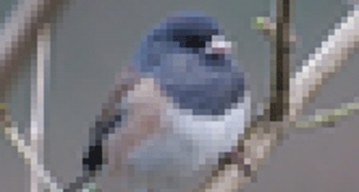
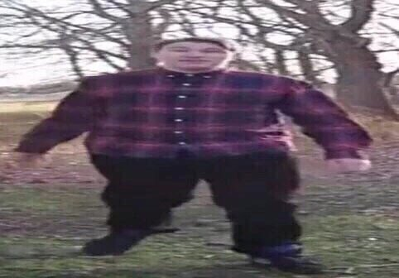
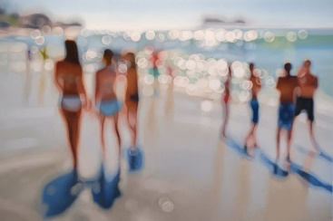

Watermarked Blurry Stretched Pixelated
Choose Your Own History Project Rubric
Name:
Topic: |  |  | Project:
Criteria | 4  Proficient | 3  Standard | 2  Emerging | 1  Working | 0  Not Applicable
Researching:  Selection and development of themes, problems, issues, techniques and processes through study, research or exploration  (completed before project)  /4 | Demonstrates exemplary ability to plan and conduct in-depth, personal research that results in highly successful solution of complex themes, problems and issues; uses wide variety of sources to gather information; works independently  SAVED research information IN YOUR NOTEBOOK | Conducts sufficient planning and research enabling selection, development and solution of complex and personal themes, problems, issues, techniques or processes; uses a wide variety of appropriate sources to gather information; works somewhat independently – SAVED in NOTEBOOK | Often self-directed with frequent teacher help is able to plan and conduct research that leads to selection, development or solution of a few satisfactory themes, problems, issues, techniques or processes; uses several meaningful sources to gather information; Needs teacher to tell next step in process | Is unable to plan or conduct research without continuous help, therefore selection, development or solution of themes, problems and issues, techniques or processes is entirely dependent on teacher; makes no deliberate attempt to explore appropriate sources; | Did not do any research prior to project.  Only used Wikipedia or other non-credible sources
Historical Content:  Establish historical significance,  use of primary source evidence,  identify continuity and change,  analyze cause and consequence.  Take historical perspectives, and  understand the ethical dimension of historical interpretations.  /8 | Demonstrates a  thorough/strong understanding of the historical content and is significance to Canada’s history.  Presents a logical  interpretation of historical events grounded in evidence  Incorporates both primary and secondary  sources into analysis, stablishing a strong argument point.  Clearly uses and highlights 4 + historical thinking concepts | Demonstrates a good understanding  of the historical Content  Presents a logical  Interpretation of historical events mostly  grounded in evidence  Incorporates both primary and secondary  sources into analysis,  establishing a reasonable  argument/point.  Uses and highlights 3 historical thinking concepts | Demonstrates  some understanding  of the historical  Content  Presents an inconsistent  Interpretation of historical events weakly  grounded in evidence  Establishes an argument/point but needs more work.  Historical thinking concepts are not well displayed | Demonstrates  little understanding  of the historical  content  Presents an  inconsistent  interpretation of historical events, not  grounded in  evidence  Sources establish a  weak argument/point that does not fit  Too much irrelevant information | Not grade level  Historical inaccuracies
Criteria List  ( on project outline)  /4 | Student when beyond the basic outline for the project | Student followed criteria list and completed the basic minimum expectation of the project | Student completed project but missed a mandatory outcome | Student is missing multiple mandatory out comes.  or  Project is incomplete | Student did complete mandatory criteria list located on project outline
Craftsmanship, Spelling/Grammar &Technical Editing  /4 | Project is well created with pride. Minimal errors. Excellent vocabulary, over well crafted. | Project has minor errors. Errors in the project do not distract from the project. Student uses graded level vocabulary. Student put consideration into the project. | Student has several spelling and grammar or technology errors that distract from the project. Student still has consideration project. | Project is poorly crafted. Distracting errors that make the project hard to understand. | Student handed in a project that was not of high school level see note attached
Project Step Guide
Plagiarized writing will be an automatic 0/20 /20
Step 1: Identify and develop your topic: Selecting a topic can be the most challenging part of the project but it’s important for you to try and pick a topic that is of interest to you!
Step 2: Do a preliminary search for information: Do an initial search to determine whether there is enough information out there for your project needs. If you are unable to find a reasonable amount of information, you either need to ask for help on how to locate information or change your topic.
Step 3: Locate materials: Once you have directions you want your project to go you can start narrowing down your research into subtopics. Use a verity of credible sources for your research such as:
- Books & eBooks,
- Videos & Images,
- Articles from newspapers, magazines and journals,
- Websites
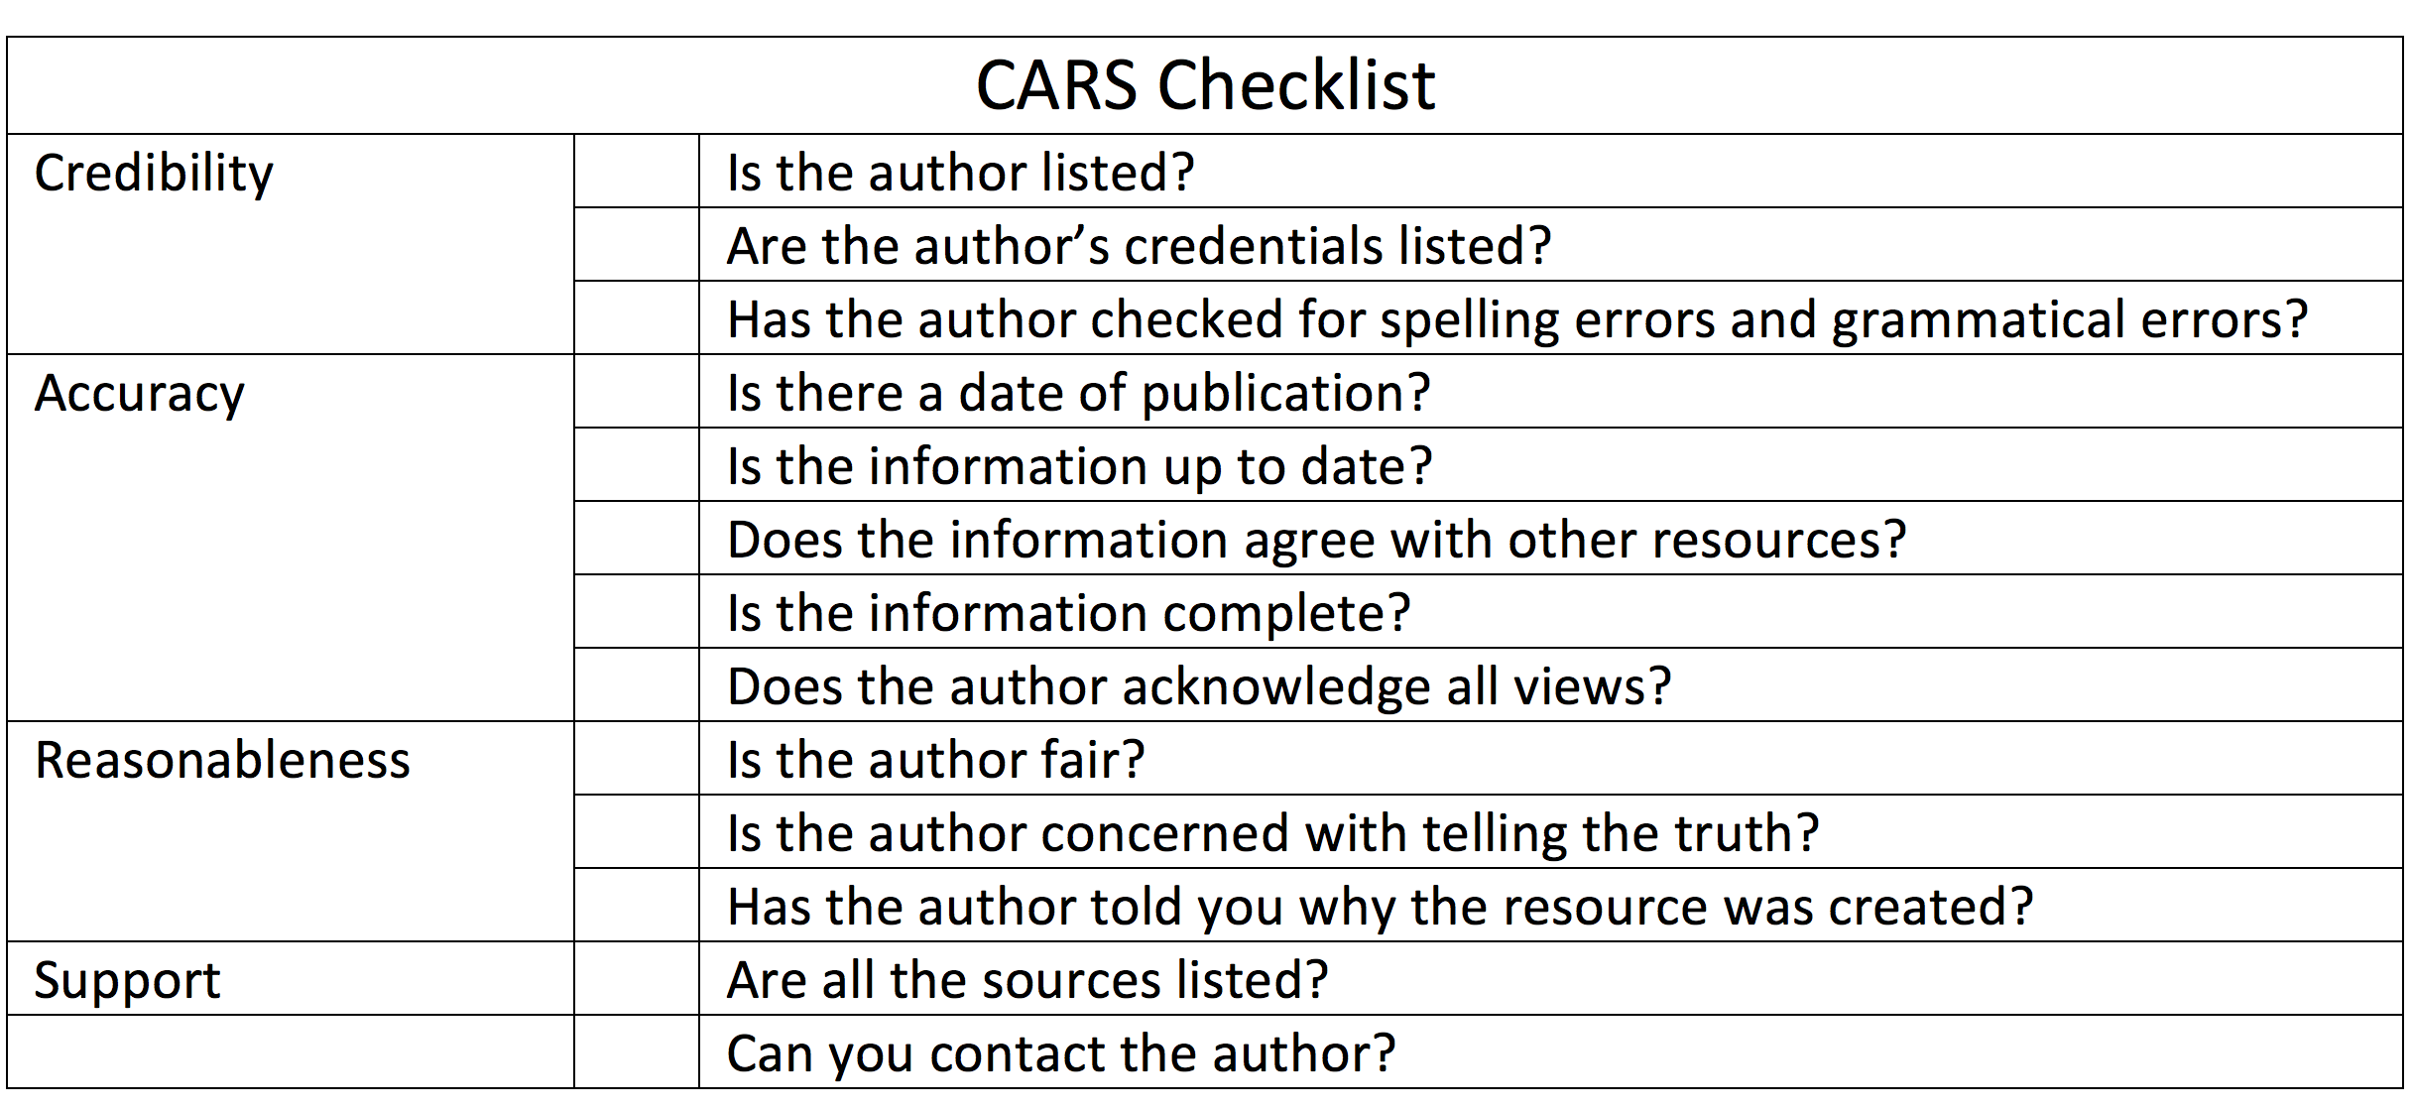
Step 4: Evaluate your sources: Use CARS to ensure your sources are good!
Step 5: Make notes: Keep note of the facts you finds and the source. You ca do this in Word doc or in your notebook.
Step 6: Create: Start constructing your project based off the notes you recorded.
Step 7: Cite your sources properly: Use the bibliography guide to source your research.
Step 8: Proofread: Before handing in your project proof read and peer edit it! Get a friend to review your work to make sure you did not miss any errors or mandatory criteria!
Revision Check List

- Fits the assignment as outlined by your instructor
- Subtopics are clear and points are supported
- Provides necessary background information for the audience to understand your points
- Subtopics moves from one idea to the next, using transitions where needed
- Provides evidence and examples
- Points in logical order
- Your spelling is Canadian not American ( colour vs color)
- Are there any points that need further explanation or detail?
- Both you and the computer have spell-checked your paper
- Word endings (-es, -s, -'s, and -s') have all been used correctly
- Homonyms such as there, their, and they're have been used correctly
- Beginnings of sentences and proper nouns have been capitalized
- Sources have been cited correctly
- The paper is formatted correctly
- The draft has been read aloud (reading aloud helps you find the errors)
- Is the voice or style I am using appropriate for my audience and project?
- You have received feedback from a friend, family, classmate, EA or teacher on your project
- Did I review the historical content with my teacher to ensure it meets expectations?

